Activate Business year for Germany Sales Org (DE00)
Step1: Login as system Administrator.
- Go to App Launched and type Sales Organization
- Open Germany (DE00) sales organization from list view
- Click on Edit
- Go to general settings and uncheck the attribute Has Activated Business Years
- Click on save
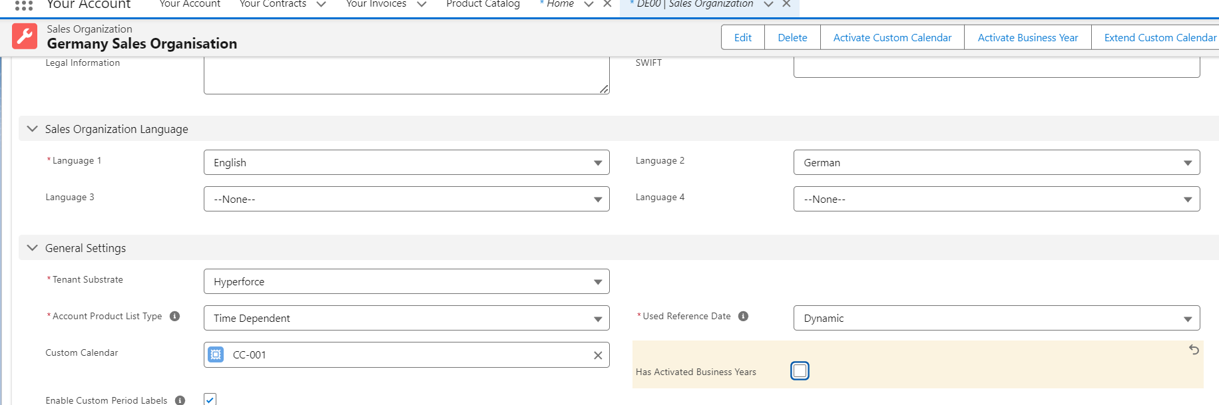
Step2: Click On Activate Business year button on top right corner
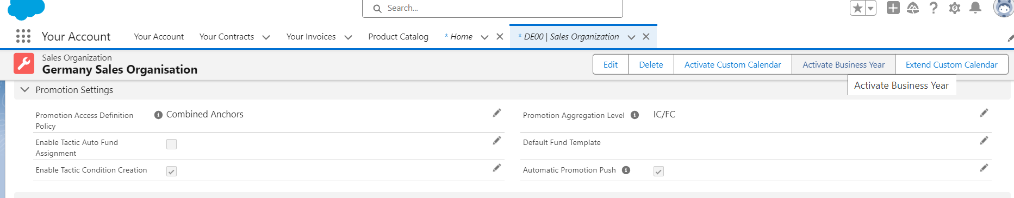
Step 3: Click Confirm on the pop up. Post confirmation Business will be activated
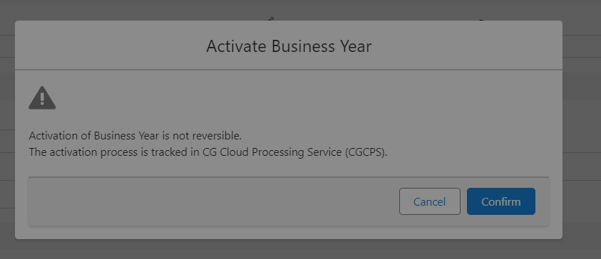
Step4: Validate if year is already activated or not
- Please check the attribute Has Activated Business Years. If must be checked.
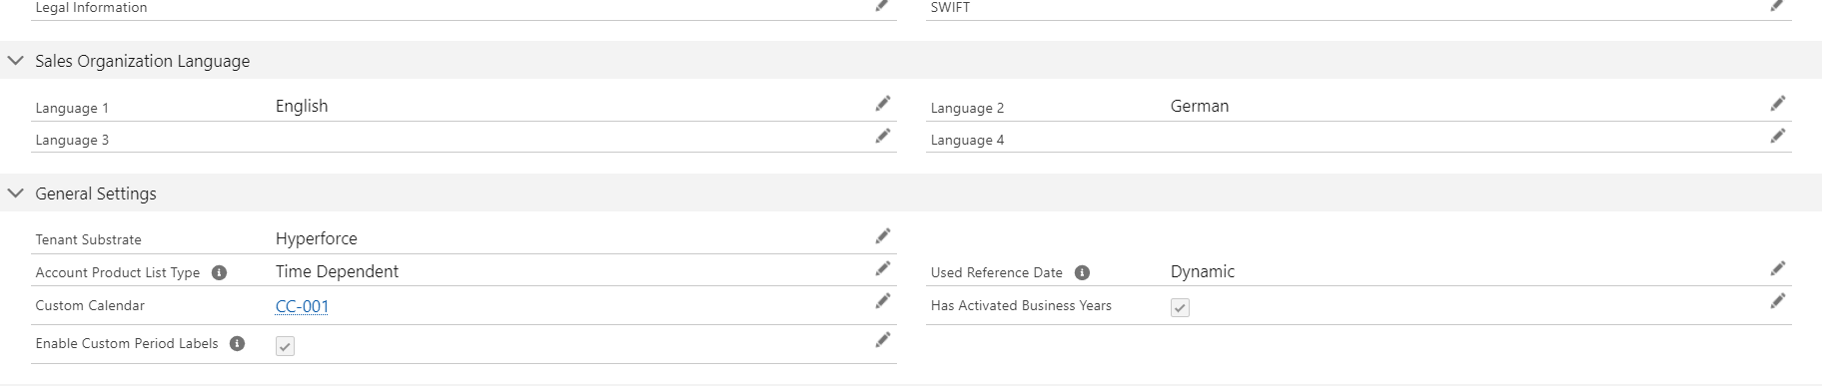
Step 5: Process the SF data synchronization
- Switch to processing Service user and complete step 5 and 6
- Go to App Launcher and select SF data sync
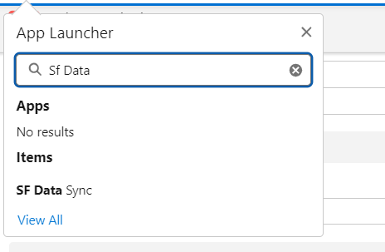
- Stop Continuous Sync button
- Select All item from left to right list items
- Click On Re-Sync button
Step 6: Click on Start Continuous sync button
